DBOX API INFORMATION FOR JMP

Authentication
To use any of the API endpoints in DBOX, you need to first get an authentication token by logging in to the API.
I have created an account you can use for the testing site, the credentials are as follows:
- Username: changiz.tavakoli@jmpsolutions.com
- Password: JMP5olut1on5@SCG
To authenticate you must use the following API endpoint:
POST – https://stresscretetest.dboxnow.com/api/token/v2
The request should use application/json as the Content-Type and the body should be a JSON object with two parameters, Username and Password. I have attached a screenshot below of an example of me calling the API and the response you will get. I am using POSTman as my program to test the API.
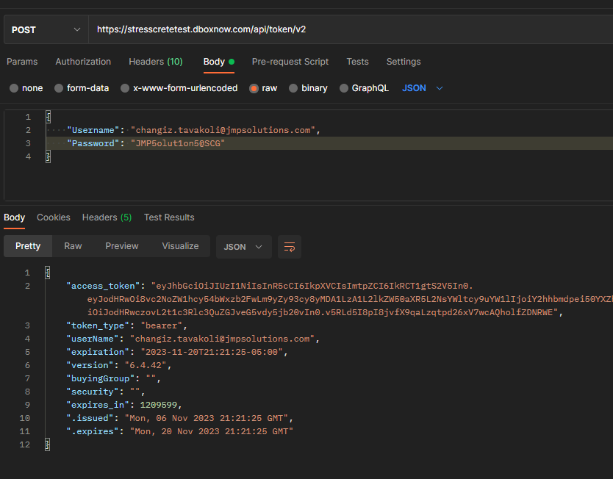
If you look at the response in the screenshot above, you can see an “access_token” is returned. This is the value you need to provide in the Header of any other request to the API. I will show in the section below how to use the value to authorize with the other API endpoints.

DBOX Multi Level BOM Search
There are a few endpoints you can take advantage of here:
- GET – https://stresscretetest.dboxnow.com/api/Search/61
- GET – https://stresscretetest.dboxnow.com/api/Search/61/Count
- POST – https://stresscretetest.dboxnow.com/api/Search
- POST – https://stresscretetest.dboxnow.com/api/Search/Count
As you can see, these are what we consider “Search” endpoints. Search is a tool we use to allow our customers to build custom data views/data grids to explore data in their system using a SQL query.
The benefit to using this endpoint is that, if all you want to do is retrieve data, you can create a new Search in OrderStream and use it to get data without needing Seradex to program an enhancement into the API to retrieve any data you might need. The downside is that the data returned in the response is a little complex because it’s dynamic depending on which Search you use.
For your request, I have created a search that has the ID of 61. We can use this Search to query data related to the Bill of Material for any Item.
The two GET requests are used to just get a default set of data for the related Search with no specific Item filters. The main use of this is that the response it provides can be used as the body of the POST requests. Combined with the Filters the POST can be used to return more specific data catered to your needs.

Sample GET Request
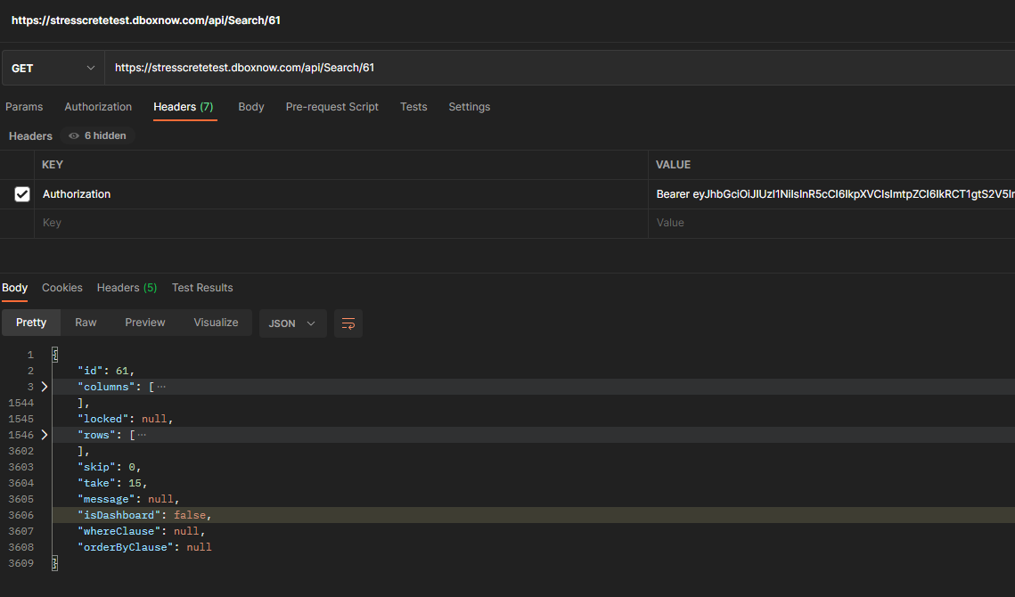
As you can see in the screenshot above I have added an “Authorization” property to the Header of my request. For the value, I have entered the word “Bearer” followed by a space, and then the value returned in the “Access_token” property of the Token request from earlier.
As you can see in the response above, there are quite a few properties. The most important ones to us are the columns, rows, id, skip and take.
The columns object returns an array of all the columns there would be if this were a grid/table. If you dive deeper into the columns array, you will see that each column object has filters, these are what we use to filter the request to return more specific information. The rows object provides an array of rows which is the data returned by the query. Each row has multiple properties/objects, each of these will correspond to a rowkey in the columns list.
For this search for example, if I were using Javascript to interact with this object and I wanted to get the value of the ItemNo in the first row of data returned by the query and I know the rowkey value, I could access it using the following.
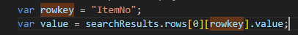
This is implying that the object searchResults is the JSON object returned in the response of the GET/POST. The above statement would set the value variable to the ItemNo of the first row of data returned by the query.

POST Request Sample
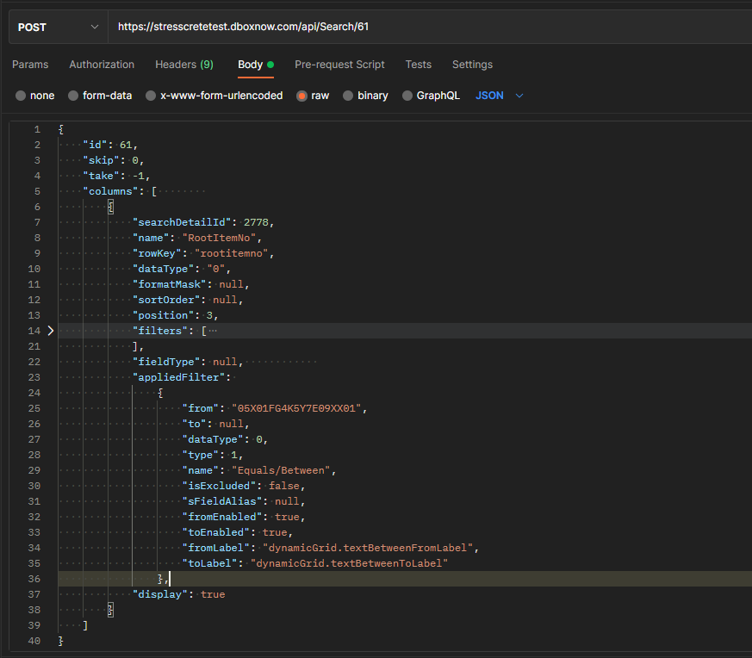
In the above example, I have used the “equals/between” filter (provided in the list of filters for each column as an applied filter. What this does is apply a WHERE clause to the query based on the values you use in the “from” and “to” properties of the applied filter, depending on which type of filter you use. The example above would call my query and add the following clause to the end of the SQL Query:
- WHERE RootItemNo = ‘05X01FG4K5Y7E09XX01’
Passing in a value of -1 for the take will return all results. Be sure when using this argument that you do have a column with an applied filter.
A quick note, the data returned by this call may not be perfectly accurate, if you approve us to go forward with creating a dedicated API call to retrieve Item BOMs and Labour we would create a dedicated response object that would be very different from the Search above, so don’t plan on designing your solution around this object.

Search Count Endpoints
I provided these earlier, but the two requests that have “Count” in the URL can be used to determine exactly how many rows of data there are available for your search and your search filter.
- GET – https://stresscretetest.dboxnow.com/api/Search/61/Count
- POST – https://stresscretetest.dboxnow.com/api/Search/Count
These will not return the data, but instead return a number to tell you how many results there are for a matching get/post request. So, if you want to know how many results your filtered query will take, you can pass in the same JSON body to the Count POST and it will return a number that is the number of rows. You can then use this value in the “take” parameter of your POST Search request to limit it to return exactly as many rows as your filter would provide. The reason we have this is because we use this API for a grid/table with paging, which is why we have a skip/limit parameter, but if you just need all the data for your filter you can provide a skip of 0 and a take equal to or greater than the response of the Count endpoint.
If this document still doesn’t adequately clarify how to use our API please let us know and we can figure out where to go from here.

